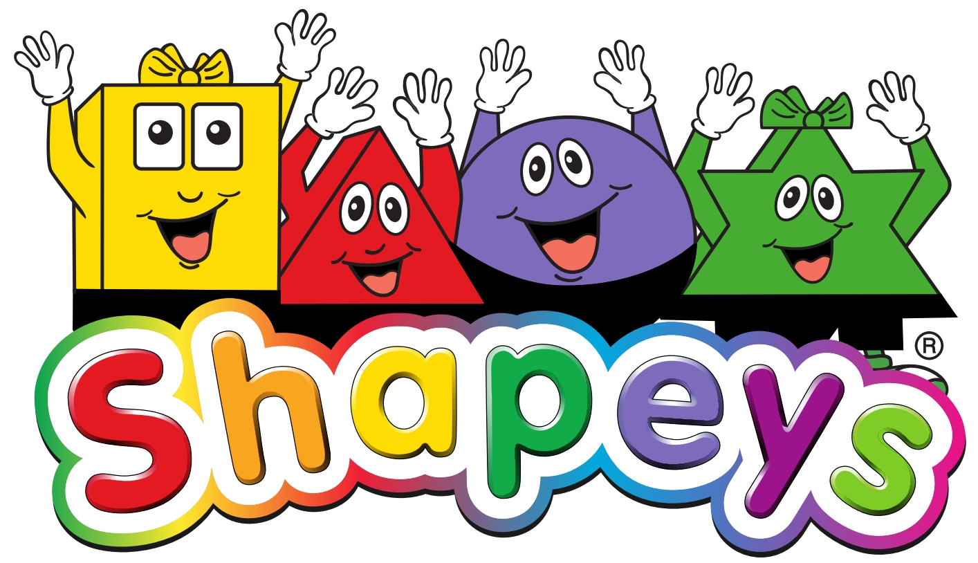
SHAPEYS®
INTERNATIONAL RIGHTS GUIDE
2026 EDITION
Shapeys Phonics • 48 Reading and 16 Activity Books
English • Mathematics • Science • Life Skills

A publisher and licensing guide for the Shapeys educational programme

1. Rights at a Glance
Shapeys® is a children's educational publishing programme created, written and illustrated by Adrian Alexander.
The full range includes;
- A full phonics learning system, Shapeys Teaching English Phonics System (STEPS) comprising of three instruction manuals, exercise books, flashcards, wall charts, word cards and assessment sheets.
- The Shapeys book series comprising 48 reading books across four learning areas, supported by 16 activity books.

The programme is designed as a connected educational range, taking young learners through basic letters and sounds and progressing through to stories, language development, subject learning and practical life skills.

STEPS Phonics
Learning area |  | Activity books
Sounds | Teaching Manual Step 1 | 1
Letter Sounds | Teaching Manual Step 2 | 1
Tricky Words | Teaching Manual Step 3 | 1
Practice | Exercise Book Step 2 | 1
Practice | Exercise Book Step 3 | 1
TOTAL |  | 5

Shapeys Book Series
Learning area | Level 1 | Level 2 | Total readers | Activity books
English | 12 | 12 | 24 | 4
Mathematics | 4 | 4 | 8 | 4
Science | 4 | 4 | 8 | 4
Life Skills | 4 | 4 | 8 | 4
TOTAL | 24 | 24 | 48 | 16

Rights position
Shapeys Education (Pte)Ltd, has all the global rights in all formats for the Shapeys® brand via a license granted by the owner Adrian Alexander.
This Rights Guide is intended to identify the rights and licensing opportunities that may be discussed with publishers and licensing partners. Specific rights, territories, formats, languages, term, exclusivity, minimum guarantees, royalties and other commercial terms are subject to a separate written agreement.

2. The Shapeys Programme

Phonics as the English entry point
The Shapeys English programme is led by its phonics system Shapeys Teaching English Phonics (STEPS).
The website and publisher materials can therefore position phonics, sound progression, flashcards, lesson resources and supporting video as the foundation through which publishers enter the English programme.
The programme is built around four recurring Shapeys characters and everyday learning situations. The characters introduce the basic phonic sounds and letters. They continue to be actively involved throughout book series.

The book series uses British English and covers four complementary areas: English, Mathematics, Science and Life Skills. Level 1 builds on the phonics knowledge and provides foundational language and concepts; Level 2 extends the programme with more developed language, concepts and activities.

3. Rights Available for Discussion
Rights category | Scope
Print publishing rights | Publication of the Shapeys reading books and/or activity books in physical print editions.
Translation rights | Translation and publication in agreed languages, subject to approval of translations and terminology.
Territorial rights | Rights may be discussed by country, region or agreed territory.
Educational/institutional rights | Use and distribution through schools, educational organisations and institutional channels where agreed.
Digital publishing rights | E-books, digital editions, downloadable educational products and other agreed digital formats.
Audio rights | Audiobook, narrated reading and other audio adaptations, subject to format and approval.
Interactive/learning-platform rights | Use within approved educational apps, learning platforms, games or interactive products.
Video/animation rights | Adaptation of characters, stories or educational material into video or animation, subject to separate agreement.
Phonics rights | Licensing of agreed elements of the Shapeys phonics programme, including supporting teaching materials.
Teacher-resource rights | Publication and distribution of agreed lesson plans, worksheets, flashcards and other supporting resources.
Merchandising rights | Character and brand merchandise may be discussed separately, with product categories and approvals specified in contract.
Promotional rights | Use of approved Shapeys artwork, characters, extracts and programme information for marketing the licensed edition.

4. Licensing Framework
Shapeys can be licensed as a complete programme, as a subject range, as selected titles, or through agreed combinations of print and supporting educational rights. A publisher's proposal can therefore be tailored to its market, distribution model and educational strategy.
Possible licence structure | Typical scope to discuss
Complete programme | All phonics materials. All four subjects and agreed levels across an agreed territory.
English programme | 48 English readers, plus agreed English 16 activity books and phonics/supporting resources.
Subject licence | Mathematics, Science or Life Skills reader range, with associated activity books where agreed.
Level licence | Level 1 or Level 2 readers within selected subjects.
Selected-title licence | A defined list of individual titles.
Print + digital | Physical editions together with agreed digital editions.
Educational package | Phonics, Readers, activity books and agreed teacher/learning resources.
Character/content licence | Specified character, story, artwork or adaptation rights under a separate agreement.

5. Territorial and Language Rights
Rights may be negotiated for individual countries, groups of countries or wider territories. Translation rights may be licensed independently from English-language rights. Shapeys can also consider localised editions where selected educational content, examples or pages are adapted for an agreed market, subject to prior approval.

6. Exclusivity
Exclusive and non-exclusive arrangements may be considered. Any exclusivity should be defined precisely by territory, language, format, subject, title range, distribution channel and licence term. No exclusivity should be assumed from initial discussions or catalogue availability.

7. Rights Approval and Quality Control
Licensed editions should preserve the integrity of the Shapeys brand, characters and educational purpose. Translations, adaptations, new artwork, localisations, cover designs, substantial editorial changes and derivative products should be subject to an agreed approval process.

8. Phonics and Educational Resource Rights
The following schedule introduces the main items included in STEPS.
STEPS Phonics
Learning area |  | Activity books
Sounds | Teaching Manual Step 1 | 1
Letter Sounds | Teaching Manual Step 2 | 1
Tricky Words | Teaching Manual Step 3 | 1
Practice | Exercise Book Step 2 | 1
Practice | Exercise Book Step 3 | 1
Classroom | Flashcards, Wallcharts, Word Cards | 1 Set

8. The 48-Book Rights Schedule
The following schedule identifies the current 48 reading books by subject and level. Each title can be considered for the rights categories described in this Guide, subject to availability and a separate licence.

English — Level 1
Title | ISBN | Format | Learning focus
Shapeys Talking Fruit | 978-981-08-7309-7 | 16 pp | Grammar and fruit vocabulary
Shapeys “I Have Pink Hair” | 978-982-08-7310-3 | 16 pp | I + have; parts of the body
Shapeys “Who Will Do It?” | 978-981-08-7311-0 | 16 pp | Who?; and; vehicles and people
Shapeys Home Sweet Home | 978-981-08-7312-7 | 16 pp | This/That; things in the house
Shapeys We Are The Shapeys | 978-981-07-5434-1 | 16 pp | We; family vocabulary
Shapeys Family Time | 978-981-07-5435-8 | 16 pp | Pronouns; common greetings
Shapeys School Days | 978-981-07-5436-5 | 16 pp | School and stationery vocabulary
Shapeys Where We Live | 978-981-07-5437-2 | 16 pp | Possessives; places and vehicles
Shapeys Baw’s Garden | 978-981-07-5438-9 | 16 pp | Demonstratives; prepositions; insects
Shapeys Farmwork Is Fun | 978-981-07-5439-6 | 16 pp | Prepositions; farm animals
Shapeys Where Is It? | 978-981-07-5440-2 | 16 pp | And; plurals; household vocabulary
Shapeys Mimi’s Birthday | 978-981-07-5441-9 | 16 pp | Celebrations vocabulary

English — Level 2
Title | ISBN | Format | Learning focus
Shapeys Sun And Rain | 978-981-08-7315-8 | 24 pp | Present tense; time and weather
Shapeys Ride And Shop | 978-981-08-7316-5 | 24 pp | Present continuous; supermarket
Shapeys Fun And Games | 978-981-08-7317-2 | 24 pp | Subject–verb agreement; sports
Shapeys Helping Out | 978-981-08-7318-9 | 24 pp | Will; descriptive adjectives; tasks
Shapeys Trains and Planes | 978-981-07-5442-6 | 24 pp | The; collective nouns; vehicles
Shapeys Fancy Dress Day | 978-981-07-5443-3 | 24 pp | Has/have; feelings and appearances
Shapeys Out and About | 978-981-07-5444-0 | 24 pp | Prepositions; buildings and places
Shapeys Our World | 978-981-07-5445-7 | 24 pp | Countable/uncountable nouns; flags
Shapeys A Trip To The Zoo | 978-981-07-5446-4 | 24 pp | Quantifiers; animals and senses
Shapeys The Circus Is In Town | 978-981-07-5447-1 | 24 pp | Question words; circus vocabulary
Shapeys Playtime | 978-981-07-5448-8 | 24 pp | Doubles; adverbs; playground
Shapeys At The Library | 978-981-07-5449-5 | 24 pp | Reflexive pronouns; library vocabulary

Mathematics — Level 1
Title | ISBN | Format | Learning focus
Shapeys Getting Ready | 978-981-08-7321-9 | 16 pp | Numbers 1–10; subtraction
Shapeys Let’s Measure | 978-981-08-7322-6 | 16 pp | Length, height and mass
Shapeys Boo’s Day | 978-981-08-7323-3 | 16 pp | Time to the hour
Shapeys Let’s Go Shopping | 978-981-08-7324-0 | 16 pp | Coins, value and total cost

Mathematics — Level 2
Title | ISBN | Format | Learning focus
Shapeys The Treasure Hunt | 978-981-08-7328-8 | 24 pp | Ordinal numbers and positions
Shapeys Shaping Up | 978-981-08-7329-5 | 24 pp | 3-D shapes
Shapeys Group And Share | 978-981-08-7330-1 | 24 pp | Sharing quantities
Shapeys The Birthday Present | 978-981-08-7331-8 | 24 pp | Coins/notes; adding and subtracting money

Science — Level 1
Title | ISBN | Format | Learning focus
Shapeys What’s For Breakfast? | 978-981-08-7334-9 | 16 pp | Hot and cold
Shapeys Mix Them Up | 978-981-08-7335-6 | 16 pp | Primary and secondary colours
Shapeys Let’s Visit The Farm | 978-981-08-7336-3 | 16 pp | Animals and their young
Shapeys The Strange Dream | 978-981-08-7337-0 | 16 pp | Properties of materials

Science — Level 2
Title | ISBN | Format | Learning focus
Shapeys Common Senses | 978-981-08-7340-0 | 24 pp | Five senses and sense organs
Shapeys In The Garden | 978-981-08-7341-7 | 24 pp | Plants and plant parts
Shapeys Two And Two | 978-981-08-7342-4 | 24 pp | Healthy diet
Shapeys The Butterfly | 978-981-08-7343-1 | 24 pp | Butterfly life cycle

Life Skills — Level 1
Title | ISBN | Format | Learning focus
Shapeys You Can Do It! | 978-981-08-7346-2 | 16 pp | Building self-esteem
Shapeys Little Lessons | 978-981-08-7347-9 | 16 pp | Good habits
Shapeys The Missing Lunchbox | 978-981-08-7348-6 | 24 pp | Being honest
Shapeys We Are Friends | 978-981-08-7349-3 | 24 pp | Living in harmony

Life Skills — Level 2
Title | ISBN | Format | Learning focus
Shapeys We Can Help | 978-981-08-7352-3 | 24 pp | Caring, helping and thankfulness
Shapeys Fun At The Fair | 978-981-08-7353-0 | 24 pp | Being a good friend
Shapeys Drip, Drip, Drip! | 978-981-08-7354-7 | 24 pp | Knowing what is important
Shapeys At The Airport | 978-981-08-7355-4 | 24 pp | Understanding how things work

9. Supporting Activity Books
Sixteen activity books complement the 48 reading books. They can be licensed with the corresponding subject range or as part of a broader educational package.
Activity book | ISBN
English Activity Book Level 1 Part 1 | 978-981-08-7313-4
English Activity Book Level 1 Part 2 | 978-981-08-7314-1
English Activity Book Level 2 Part 1 | 978-981-08-7319-6
English Activity Book Level 2 Part 2 | 978-981-08-7320-2
Mathematics Activity Book Level 1 Part 1 | 978-981-08-7325-7
Mathematics Activity Book Level 1 Part 2 | 978-981-7327-1
Mathematics Activity Book Level 2 Part 1 | 978-981-08-7332-5
Mathematics Activity Book Level 2 Part 2 | 978-981-08-7333-2
Science Activity Book Level 1 Part 1 | 978-981-08-7338-7
Science Activity Book Level 1 Part 2 | 978-981-08-7339-4
Science Activity Book Level 2 Part 1 | 978-981-08-7344-8
Science Activity Book Level 2 Part 2 | 978-981-08-7345-5
Life Skills Activity Book Level 1 Part 1 | 978-981-08-7350-9
Life Skills Activity Book Level 1 Part 2 | 978-981-08-7351-6
Life Skills Activity Book Level 2 Part 1 | 978-981-08-7356-1
Life Skills Activity Book Level 2 Part 2 | 978-981-08-7357-8

11. Adaptation and Derivative Rights
Format / opportunity | Potential licensed use
E-books | Digital editions of selected or complete reading ranges.
Educational apps | Interactive reading, phonics, vocabulary, quizzes or subject-learning experiences.
Video | Animated or live-action educational adaptations using approved Shapeys content.
Audio | Narrated stories, listening exercises and audio learning resources.
Games | Educational games based on agreed characters, concepts or stories.
Teacher resources | Localised teacher guides, worksheets, flashcards and classroom materials.
Merchandise | Approved character-led products and educational merchandise.

12. What a Publisher Proposal Should Include
- Publisher/company profile and relevant educational publishing experience.
- Territory or territories requested.
- Language(s) requested.
- Titles, subjects or levels requested.
- Print, digital, audio, video or other formats requested.
- Exclusive or non-exclusive rights requested.
- Proposed distribution channels.
- Expected launch timing and initial print/digital plans.
- Proposed licence term.
- Proposed commercial structure, including advance/guarantee and royalty proposal where applicable.
- Marketing and sales plan.
- Any proposed localisation, translation or adaptation.

13. Rights Enquiry Process
Publishers and licensing partners are invited to contact Shapeys with their proposed territory, language, titles and rights requirements. Shapeys can then confirm the appropriate rights package, availability and commercial discussion points. No rights are granted by this Guide itself; rights become effective only under a signed written agreement.

14. Contact
Shapeys Education (Pte) Limited
10 Anson Road
International Plaza #18-11
Singapore 079903
Email: info@shapeys.com
Website: www.shapeys.com

© Adrian Alexander / Shapeys Education (Pte) Limited. All rights reserved.

