SHAPEYS® | BOOK SERIES OVERVIEW
48 illustrated Readers • English, Mathematics, Science & Life Skills
A character-led early-learning reading programme built around engaging stories, familiar situations and clear learning goals. STEPS Phonics supports English foundations; Level 1 introduces core concepts and language, while Level 2 extends vocabulary, reading confidence and understanding. The four subject collections can be used together or selected to suit learning needs. Each book has a recap page detailing the targeted learning outcomes for that book.
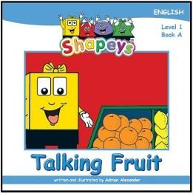  Talking Fruit  English • Level 1  978-981-08-7309-7 | 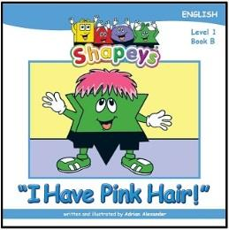  I Have Pink Hair  English • Level 1  978-981-08-7310-3 | 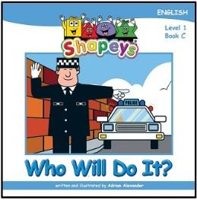  Who Will Do It?  English • Level 1  978-981-08-7311-0 | 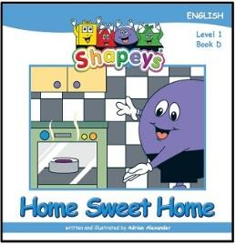  Home Sweet Home  English • Level 1  978-981-08-7312-7 | 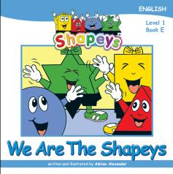  We Are The Shapeys  English • Level 1  978-981-07-5434-1 | 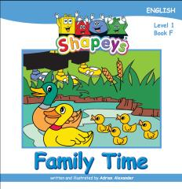  Family Time  English • Level 1  978-981-07-5435-8
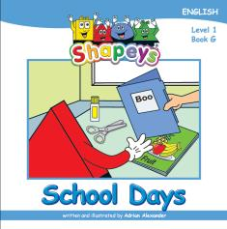  School Days  English • Level 1  978-981-07-5436-5 | 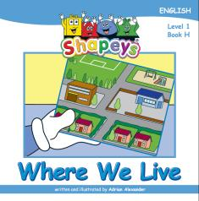  Where We Live  English • Level 1  978-981-07-5437-2 | 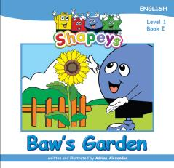  Baw's Garden  English • Level 1  978-981-07-5438-9 | 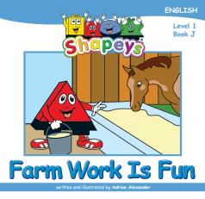  Farm Work Is Fun  English • Level 1  978-981-07-5439-6 | 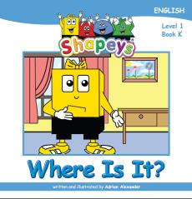  Where Is It?  English • Level 1  978-981-07-5440-2 | 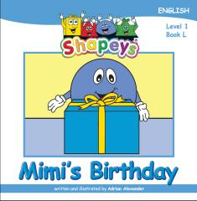  Mimi's Birthday  English • Level 1  978-981-07-5441-9
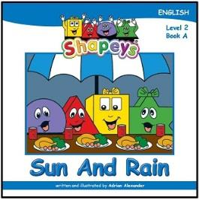  Sun And Rain  English • Level 2  978-981-08-7315-8 | 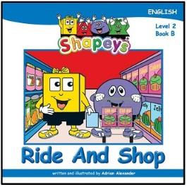  Ride And Shop  English • Level 2  978-981-08-7316-5 | 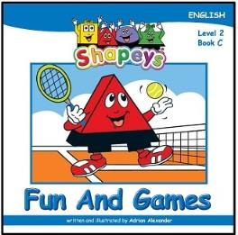  Fun And Games  English • Level 2  978-981-08-7317-2 | 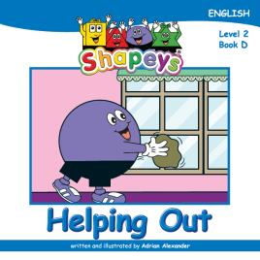  Helping Out  English • Level 2  978-981-08-7318-9 | 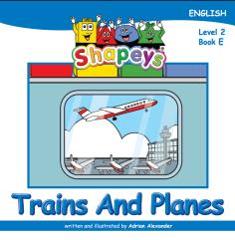  Trains and Planes  English • Level 2  978-981-07-5442-6 | 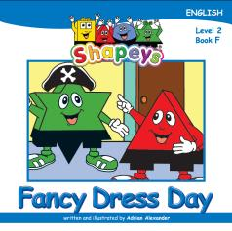  Fancy Dress Day  English • Level 2  978-981-07-5443-3
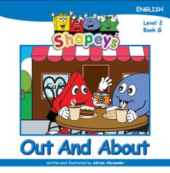  Out and About  English • Level 2  978-981-07-5444-0 | 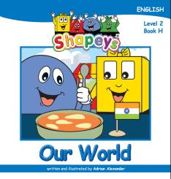  Our World  English • Level 2  978-981-07-5445-7 | 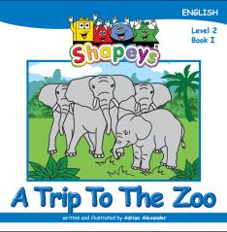  A Trip to the Zoo  English • Level 2  978-981-07-5446-4 | 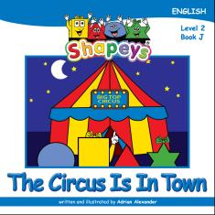  The Circus Is In Town  English • Level 2  978-981-07-5447-1 | 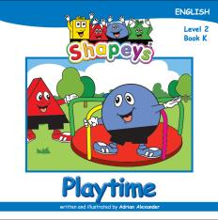  Playtime  English • Level 2  978-981-07-5448-8 | 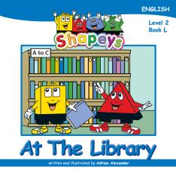  At The Library  English • Level 2  978-981-07-5449-5

THE 48-READER COLLECTION | CONTINUED
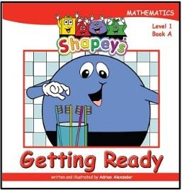  Getting Ready  Mathematics • Level 1  978-981-08-7321-9 | 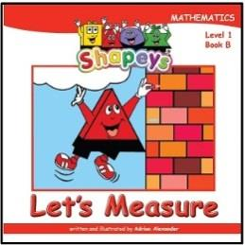  Let’s Measure  Mathematics • Level 1  978-981-08-7322-6 | 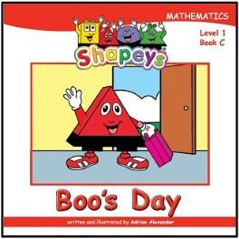  Boo’s Day  Mathematics • Level 1  978-981-08-7323-3 | 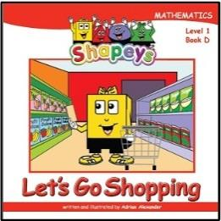  Let's Go Shopping  Mathematics • Level 1  978-981-08-7324-0 | 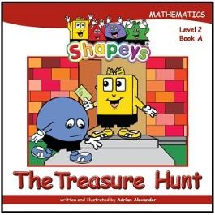  The Treasure Hunt  Mathematics • Level 2  978-981-08-7328-8 | 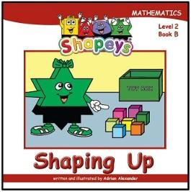  Shaping Up  Mathematics • Level 2  978-981-08-7329-5
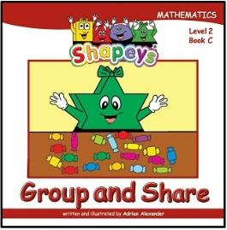  Group And Share  Mathematics • Level 2  978-981-08-7330-1 | 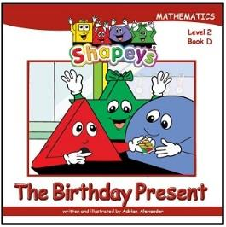  The Birthday Present  Mathematics • Level 2  978-981-08-7331-8 | 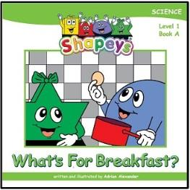  What’s For Breakfast?  Science • Level 1  978-981-08-7334-9 | 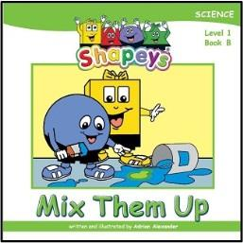  Mix Them Up  Science • Level 1  978-981-08-7335-6 | 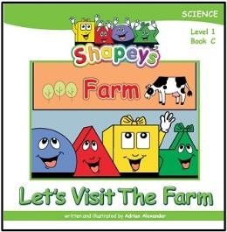  Let’s Visit The Farm  Science • Level 1  978-981-08-7336-3 | 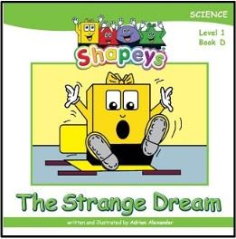  The Strange Dream  Science • Level 1  978-981-08-7337-0
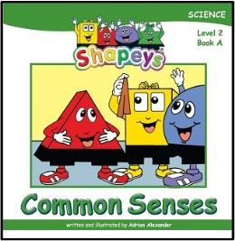  Common Senses  Science • Level 2  978-981-08-7340-0 | 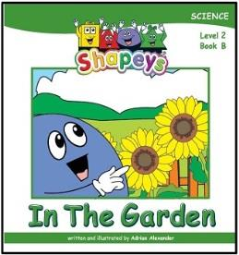  In The Garden  Science • Level 2  978-981-08-7341-7 | 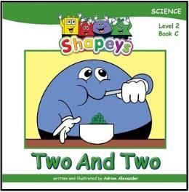  Two And Two  Science • Level 2  978-981-08-7342-4 | 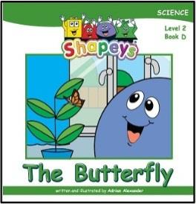  The Butterfly  Science • Level 2  978-981-08-7343-1 | 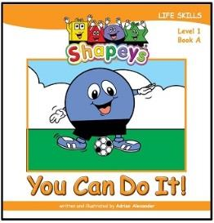  You Can Do It!  Life Skills • Level 1  978-981-08-7346-2 | 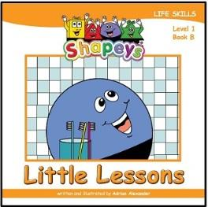  Little Lessons  Life Skills • Level 1  978-981-08-7347-9
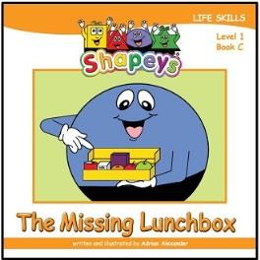  The Missing Lunchbox  Life Skills • Level 1  978-981-08-7348-6 | 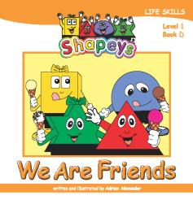  We Are Friends  Life Skills • Level 1  978-981-08-7349-3 | 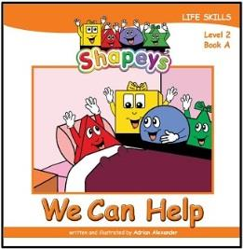  We Can Help  Life Skills • Level 2  978-981-08-7352-3 | 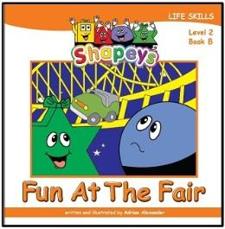  Fun At The Fair  Life Skills • Level 2  978-981-08-7353-0 | 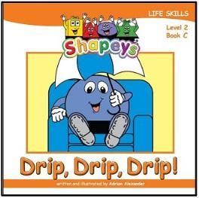  Drip, Drip, Drip!  Life Skills • Level 2  978-981-08-7354-7 | 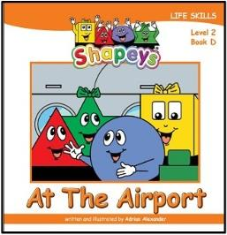  At The Airport  Life Skills • Level 2  978-981-08-7355-4

SHAPEYS® | ACTIVITY BOOKS
16 Activity Books • Four subjects • Levels 1 & 2
The Shapeys Activity Books provide structured practice and reinforcement linked to the reading programme. Each subject includes two activity books at Level 1 and two at Level 2. The books contain 48 pages and are formatted at A4 size (210 × 297 mm).
ENGLISH
Level 1 • Part 1 | 978-981-08-7313-4 | Language, vocabulary and early literacy practice
Level 1 • Part 2 | 978-981-08-7314-1 | Further English practice and reinforcement
Level 2 • Part 1 | 978-981-08-7319-6 | Developing English skills and language use
Level 2 • Part 2 | 978-981-08-7320-2 | Extending English practice and application
MATHEMATICS
Level 1 • Part 1 | 978-981-08-7325-7 | Foundational number and mathematics activities
Level 1 • Part 2 | 978-981-7327-1 | Mathematics practice and reinforcement
Level 2 • Part 1 | 978-981-08-7332-5 | Developing mathematical concepts and skills
Level 2 • Part 2 | 978-981-08-7333-2 | Extending mathematics practice
SCIENCE
Level 1 • Part 1 | 978-981-08-7338-7 | Observation, concepts and early science practice
Level 1 • Part 2 | 978-981-08-7339-4 | Further science activities and reinforcement
Level 2 • Part 1 | 978-981-08-7344-8 | Developing science knowledge and understanding
Level 2 • Part 2 | 978-981-08-7345-5 | Extending science activities and application
LIFE SKILLS
Level 1 • Part 1 | 978-981-08-7350-9 | Family, habits, personal care, helping and teamwork
Level 1 • Part 2 | 978-981-08-7351-6 | Body, habits, school, friends and community
Level 2 • Part 1 | 978-981-08-7356-1 | Good choices, helping others, environment and pet care
Level 2 • Part 2 | 978-981-08-7357-8 | Trust, safety, asking for help and everyday situations

