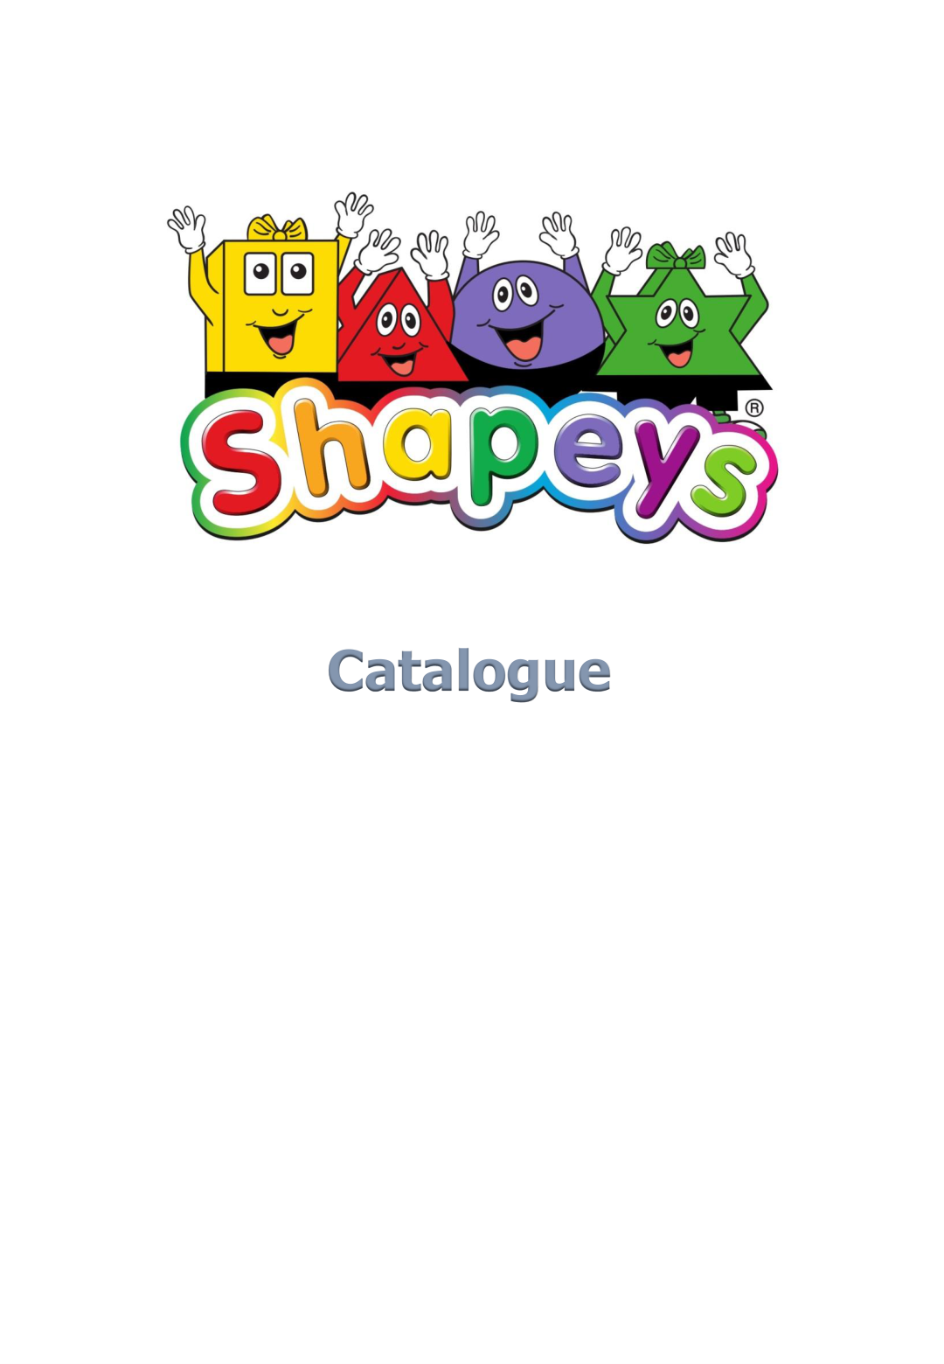
PUBLISHER CATALOGUE
2026 EDITION
Phonics • 48 Reading Books 8 Activity Books
English • Mathematics • Science • Life Skills

Contents
- 1. Shapeys at a Glance
- 2. Company, Author and Programme
- 3. Phonics — Programme Foundation
- 4. Book Series
- 5. English — Level 1
- 6. English — Level 2
- 7. English Activity Books
- 8. Mathematics — Levels 1 and 2
- 9. Mathematics Activity Books
- 10. Science — Levels 1 and 2
- 11. Science Activity Books
- 12. Life Skills — Levels 1 and 2
- 13. Life Skills Activity Books
- 14. Book Specifications and Rights
- 15. Publisher / Licensing Enquiries

1. Shapeys at a Glance
Shapeys® is a children's educational publishing programme created, written and illustrated by Adrian Alexander.
The catalogue presents a comprehensive Phonics System teaching letter sounds and 48-reading-book range across English, Mathematics, Science and Life Skills, supported by eight activity books.
Shapeys Teaching English Phonics System
Teaching Resource | Number
Step 1 Teaching Manual | 1
Step 2 Teaching Manual | 1
Step 3 Teaching Manual | 1
Step 2 Exercise Book | 1
Step 3 Exercise Book | 1
Word Cards | 940
Story Cards | 98

Teaching Manuals: 210 × 297 mm. There are 256 lesson plans contained in the Teaching Manuals. Available in hard copy and online via a dedicated website.

Shapeys Book Series
Subject | Level 1 Readers | Level 2 Readers | Activity Books
English | 12 | 12 | 4
Mathematics | 4 | 4 | 4
Science | 4 | 4 | 4
Life Skills | 4 | 4 | 4

Reading-book format: 210 × 210 mm. Level 1 titles are 16 pages; Level 2 titles are 24 pages in the source catalogue.
Activity books: 210 × 297 mm, 48 pages, 186 g.

2. Company, Author and Programme

The Company
Shapeys Education (Pte) Limited is an educational publisher based in Singapore established in 2009. The products are based around the four Shapeys® characters. The stories are based on everyday experiences, places and situations young children are likely to encounter.

The Author
Adrian Alexander created, wrote and illustrated the Shapeys® educational books. He is an English teacher from Great Britain.

The Team
Adrian was assisted by a team of international editors and English teachers.

The Research
The team studied the teaching of English through school curriculums in the UK, the USA and Singapore. The results were used to create the series for school use, either as main teaching books forming a curriculum or as a supplementary series. It also states that the series can be used for home schooling or entertainment.

The Language
The language used throughout the books is British English.

Rights
Shapeys Education (Pte) Ltd holds all global rights in all formats for the Shapeys® brand on licence from Adrian Alexander.

3. Phonics — Programme Foundation
For the 2026 Publisher Catalogue, Phonics should be presented as the entry point to the Shapeys English programme.
- Phonics overview
Step | Number of Weeks | Activity | Learning Objective
Step 1 | 7 Weeks | 77 Lessons and Activities | Introduce environmental sounds, instruments, body percussion, rhythm and rhyme, alliteration, voice sounds, oral blending and segmentation.
Step 2 | 7 Weeks | 28 Lessons 49 Activities | Recognise a letter, say the letter, write the letter.
Step 3 | 9 Weeks | 51 Lessons 57 Activities | Introduce a sound for various double letter combinations  Introduce an alphabet song  Introduce capital letters  Introduce the remaining words in the top 100 used words
Total | 23 Weeks | 256 Lesson 184 Activities

4. English — Level 1
The titles, bibliographic specifications and learning focuses below are taken from the supplied Shapeys catalogue.
Title | ISBN | Format / Size | Learning Focus
Shapeys Talking Fruit | 978-981-08-7309-7 | 210 × 210 mm  16 pages • 76 g | Grammar: I + am, You + are, is. Vocabulary: colours, names of fruit.
Shapeys “I Have Pink Hair” | 978-982-08-7310-3 | 210 × 210 mm  16 pages • 76 g | Grammar: I + have. Vocabulary: parts of the body.
Shapeys “Who Will Do It?” | 978-981-08-7311-0 | 210 × 210 mm  16 pages • 76 g | Grammar: question word — who?; conjunction — and. Vocabulary: vehicles, people.
Shapeys Home Sweet Home | 978-981-08-7312-7 | 210 × 210 mm  16 pages • 76 g | Grammar: This + is, That + is, a, am. Vocabulary: things in the house.
Shapeys We Are The Shapeys | 978-981-07-5434-1 | 210 × 210 mm  16 pages • 76 g | Grammar: personal pronoun — we. Vocabulary: family, parents, father, mother, sister, brother.
Shapeys Family Time | 978-981-07-5435-8 | 210 × 210 mm  16 pages • 76 g | Grammar: personal pronouns — she, he, you, they. Vocabulary: common greetings — hello, goodnight, goodbye.
Shapeys School Days | 978-981-07-5436-5 | 210 × 210 mm  16 pages • 76 g | Vocabulary: words associated with school and stationery.
Shapeys Where We Live | 978-981-07-5437-2 | 210 × 210 mm  16 pages • 76 g | Grammar: possessive forms — my, your, that, this; question word — what? Vocabulary: vehicles, places.
Shapeys Baw’s Garden | 978-981-07-5438-9 | 210 × 210 mm  16 pages • 76 g | Grammar: demonstrative pronouns — these, those; prepositions — under, behind; possessive form — our. Vocabulary: insects.
Shapeys Farmwork Is Fun | 978-981-07-5439-6 | 210 × 210 mm  16 pages • 76 g | Grammar: prepositions — in, on; article — an; possessive form — their. Vocabulary: farm animals.
Shapeys Where Is It? | 978-981-07-5440-2 | 210 × 210 mm  16 pages • 76 g | Grammar: conjunction — and; plural form — adding “s”. Vocabulary: things in the house.
Shapeys Mimi’s Birthday | 978-981-07-5441-9 | 210 × 210 mm  16 pages • 76 g | Vocabulary: celebrations.

5. English — Level 2
The titles, bibliographic specifications and learning focuses below are taken from the supplied Shapeys catalogue.
Title | ISBN | Format / Size | Learning Focus
Shapeys Sun And Rain | 978-981-08-7315-8 | 210 × 210 mm  24 pages • 98 g | Grammar: simple present tense. Vocabulary: time — o’clock, weather.
Shapeys Ride And Shop | 978-981-08-7316-5 | 210 × 210 mm  24 pages • 98 g | Grammar: present continuous tense; question word — where? Vocabulary: things at the supermarket.
Shapeys Fun And Games | 978-981-08-7317-2 | 210 × 210 mm  24 pages • 98 g | Grammar: subject–verb agreement; preposition — at. Vocabulary: sports and games.
Shapeys Helping Out | 978-981-08-7318-9 | 210 × 210 mm  24 pages • 98 g | Grammar: modal — will; adjectives — descriptive words. Vocabulary: household tasks.
Shapeys Trains and Planes | 978-981-07-5442-6 | 210 × 210 mm  24 pages • 98 g | Grammar: article — the; collective nouns. Vocabulary: colour, vehicles, sounds.
Shapeys Fancy Dress Day | 978-981-07-5443-3 | 210 × 210 mm  24 pages • 98 g | Grammar: verbs — has, have. Vocabulary: feelings, appearances.
Shapeys Out and About | 978-981-07-5444-0 | 210 × 210 mm  24 pages • 98 g | Grammar: prepositions — at, into, between, beside; collective nouns — buildings; question word — where? Vocabulary: building size, places.
Shapeys Our World | 978-981-07-5445-7 | 210 × 210 mm  24 pages • 98 g | Grammar: countable and uncountable nouns; collective nouns. Vocabulary: taste, flags.
Shapeys A Trip To The Zoo | 978-981-07-5446-4 | 210 × 210 mm  24 pages • 98 g | Grammar: quantifiers — few, many. Vocabulary: sense of touch, animal sounds, animal young.
Shapeys The Circus Is In Town | 978-981-07-5447-1 | 210 × 210 mm  24 pages • 98 g | Grammar: subject + verb + agreement; question words — how, why, what. Vocabulary: circus people.
Shapeys Playtime | 978-981-07-5448-8 | 210 × 210 mm  24 pages • 98 g | Grammar: doubles — to and fro, up and down; adverbs — up, down, across. Vocabulary: playground items.
Shapeys At The Library | 978-981-07-5449-5 | 210 × 210 mm  24 pages • 98 g | Grammar: reflexive pronouns. Vocabulary: items found in a library.

6. English Activity Books
Four activity books support the English reading range: two at Level 1 and two at Level 2.
Title | ISBN | Format / Size | Learning Focus
Shapeys English Activity Book Level 1 Part 1 | 978-981-08-7313-4 | 210 × 297 mm  48 pages • 186 g | Grammar: I am, we, she, you, they, it. Vocabulary: parts of the body, common greetings, pets, colours, household items, fruit, food, school items, stationery. Punctuation: capital letters, full stop.
Shapeys English Activity Book Level 1 Part 2 | 978-981-08-7314-1 | 210 × 297 mm  48 pages • 186 g | Grammar: my, this, that, your, his, her, and, plurals, prepositions, those, these, their, in, on, an; question words — what?, who? Vocabulary: places, vehicles, insects, flowers, farm animals, occupations, furniture, appliances, electrical equipment, celebrations.
Shapeys English Activity Book Level 2 Part 1 | 978-981-08-7319-6 | 210 × 297 mm  48 pages • 186 g | Grammar: collective nouns; prepositions — above, below, at, into, beside, between; article — the; verbs — has, have; question words — where?, may? Vocabulary: shapes, food, textures, tastes, colours, sounds, vehicles, feelings, appearances, places, rooms, weather, time.
Shapeys English Activity Book Level 2 Part 2 | 978-981-08-7320-2 | 210 × 297 mm  48 pages • 186 g | Grammar: countable/uncountable/collective nouns, quantifiers, adjectives, subject–verb agreement, question words — why?, what?, when?, where?; doubles; adverbs; reflexive pronouns. Vocabulary: flags, touch, animal sounds, sports and games, circus, playground, library.

7. Mathematics — Levels 1 and 2

Mathematics Level 1
Title | ISBN | Format / Size | Learning Focus
Shapeys Getting Ready | 978-981-08-7321-9 | 210 × 210 mm  16 pages • 76 g | Number 1–10; simple subtraction.
Shapeys Let’s Measure | 978-981-08-7322-6 | 210 × 210 mm  16 pages • 76 g | Measuring length — long, longer, longest; short, shorter, shortest. Measuring height — high, higher, highest. Measuring mass — light, lighter, lightest; heavy, heavier, heaviest.
Shapeys Boo’s Day | 978-981-08-7323-3 | 210 × 210 mm  16 pages • 76 g | Telling the time to the hour.
Shapeys Let’s Go Shopping | 978-981-08-7324-0 | 210 × 210 mm  16 pages • 76 g | Coins and their value; cost of some items; total cost of some items.

Mathematics Level 2
Title | ISBN | Format / Size | Learning Focus
Shapeys The Treasure Hunt | 978-981-08-7328-8 | 210 × 210 mm  24 pages • 98 g | Ordinal numbers and their symbols — 1st, first, etc.; describing positions — second from left, etc.
Shapeys Shaping Up | 978-981-08-7329-5 | 210 × 210 mm  24 pages • 98 g | Four common three-dimensional shapes; three-dimensional shapes in objects around us.
Shapeys Group And Share | 978-981-08-7330-1 | 210 × 210 mm  24 pages • 98 g | Sharing 20 amongst four friends; sharing 16 amongst four friends; sharing 8 amongst four friends.
Shapeys The Birthday Present | 978-981-08-7331-8 | 210 × 210 mm  24 pages • 98 g | Coins and notes; adding and subtracting money.

8. Mathematics Activity Books
Title | ISBN | Format / Size | Learning Focus
Shapeys Mathematics Activity Book Level 1 Part 1 | 978-981-08-7325-7 | 210 × 297 mm  48 pages • 186 g | Counting objects; recognising 1–5; words 1–5; recognising 6–10; words 6–10; comparing numbers; more/fewer than; number patterns; count and add; adding by counting on; positions; position symbols; ordinal numbers; shapes; counting shapes; length; mass.
Shapeys Mathematics Activity Book Level 1 Part 2 | 978-981-7327-1 | 210 × 297 mm  48 pages • 186 g | Counting and knowing number words to 20; writing numerals 11–15, 16–20; writing number words 16–20; more than/fewer than; number patterns; parts and whole; counting on; subtracting by crossing out; time to the hour; coins and their value.
Shapeys Mathematics Activity Book Level 2 Part 1 | 978-981-08-7332-5 | 210 × 297 mm  48 pages • 186 g | Count by groups of tens; matching numerals and words; comparing numbers; number patterns; adding tens and ones; number bonds; subtract by crossing out; counting backwards; story sums; positions and symbols; left and right; 2-D and 3-D patterns; measuring length and mass using an object.
Shapeys Mathematics Activity Book Level 2 Part 2 | 978-981-08-7333-2 | 210 × 297 mm  48 pages • 186 g | Counting objects; recognising and writing number and number words; grouping objects in tens; tens and ones; comparing numbers; number patterns; multiplication stories; grouping equally; division stories; half past — time; coins and notes.

9. Science — Levels 1 and 2

Science Level 1
Title | ISBN | Format / Size | Learning Focus
Shapeys What’s For Breakfast? | 978-981-08-7334-9 | 210 × 210 mm  16 pages • 78 g | Temperature: hot and cold.
Shapeys Mix Them Up | 978-981-08-7335-6 | 210 × 210 mm  16 pages • 78 g | Primary and secondary colours.
Shapeys Let’s Visit The Farm | 978-981-08-7336-3 | 210 × 210 mm  16 pages • 78 g | Animals and their young; farm animals.
Shapeys The Strange Dream | 978-981-08-7337-0 | 210 × 210 mm  16 pages • 78 g | Properties of materials, such as wood, metal, plastic.

Science Level 2
Title | ISBN | Format / Size | Learning Focus
Shapeys Common Senses | 978-981-08-7340-0 | 210 × 210 mm  24 pages • 98 g | Our five senses; sense organs.
Shapeys In The Garden | 978-981-08-7341-7 | 210 × 210 mm  24 pages • 98 g | Plants and plant parts.
Shapeys Two And Two | 978-981-08-7342-4 | 210 × 210 mm  24 pages • 98 g | A healthy diet.
Shapeys The Butterfly | 978-981-08-7343-1 | 210 × 210 mm  24 pages • 98 g | The life cycle of a butterfly.

10. Science Activity Books
Title | ISBN | Format / Size | Learning Focus
Shapeys Science Activity Book Level 1 Part 1 | 978-981-08-7338-7 | 210 × 297 mm  48 pages • 186 g | Parts of our body; sense organs and senses; what can our body do?; hot and cold; colours and their names; mixing colours; types of weather; tame or wild animals; farm animals; jungle animals.
Shapeys Science Activity Book Level 1 Part 2 | 978-981-08-7339-4 | 210 × 297 mm  48 pages • 186 g | Living or non-living; living things grow; matching adult and young; names of the young; land or water; what animal is this?; parts of a plant; parts of a leaf; materials.
Shapeys Science Activity Book Level 2 Part 1 | 978-981-08-7344-8 | 210 × 297 mm  48 pages • 186 g | Five senses; colours of the rainbow; names of colours; recognising colours; parts of insects and animals; plants and their functions.
Shapeys Science Activity Book Level 2 Part 2 | 978-981-08-7345-5 | 210 × 297 mm  48 pages • 186 g | Animals that lay eggs; animals that do not lay eggs; life cycle of a butterfly; healthy food and drink; float or sink?; what material is used?; metal objects; magnetic or non-magnetic?

11. Life Skills — Levels 1 and 2

Life Skills Level 1
Title | ISBN | Format / Size | Learning Focus
Shapeys You Can Do It! | 978-981-08-7346-2 | 210 × 210 mm  16 pages • 78 g | Building self esteem.
Shapeys Little Lessons | 978-981-08-7347-9 | 210 × 210 mm  16 pages • 78 g | Cultivating good habits.
Shapeys The Missing Lunchbox | 978-981-08-7348-6 | 210 × 210 mm  24 pages • 78 g | Being honest.
Shapeys We Are Friends | 978-981-08-7349-3 | 210 × 210 mm  24 pages • 78 g | Living in harmony.

Life Skills Level 2
Title | ISBN | Format / Size | Learning Focus
Shapeys We Can Help | 978-981-08-7352-3 | 210 × 210 mm  24 pages • 98 g | Being caring, helpful and thankful.
Shapeys Fun At The Fair | 978-981-08-7353-0 | 210 × 210 mm  24 pages • 98 g | Being a good friend.
Shapeys Drip, Drip, Drip! | 978-981-08-7354-7 | 210 × 210 mm  24 pages • 98 g | Knowing what is important.
Shapeys At The Airport | 978-981-08-7355-4 | 210 × 210 mm  24 pages • 98 g | Understanding how things work.

12. Life Skills Activity Books
Title | ISBN | Format / Size | Learning Focus
Shapeys Life Skills Activity Book Level 1 Part 1 | 978-981-08-7350-9 | 210 × 297 mm  48 pages • 186 g | Knowing your family; being a good child; what can you do?; keeping clean; are you helpful?; are you obedient?; how we should treat others; be nice to our friends; doing the chores; working together; teamwork.
Shapeys Life Skills Activity Book Level 1 Part 2 | 978-981-08-7351-6 | 210 × 297 mm  48 pages • 186 g | Knowing and describing the parts of your body; good and bad habits; shadows; thinking of others; school is fun; school activities; classroom rules; being with our friends; flags, country.
Shapeys Life Skills Activity Book Level 2 Part 1 | 978-981-08-7356-1 | 210 × 297 mm  48 pages • 186 g | Good habits, bad habits; do the right thing; who should you see?; what should you use?; birthdays; helping your family and friends; festivals; recycling; care for our school, streets, gardens; know the rules; pet care.
Shapeys Life Skills Activity Books Level 2 Part 2 | 978-981-08-7357-8 | 210 × 297 mm  48 pages • 186 g | What would you do?; how to be someone people can trust; how would you handle this?; asking for help; helping our loved ones; know your signs; rules of a queue; on the street; in an aeroplane; on the bus; during a game; at public places; paying for rides.

13. Book Specifications and Rights

Phonics Teaching Manual

Teaching Manuals: 210 × 297 mm.

Reading Books
Level 1: 210 × 210 mm; 16 pages. The historical catalogue lists approximately 76 g for English and Mathematics titles and 78 g for Science and Life Skills titles.
Level 2: 210 × 210 mm; 24 pages; approximately 98 g across the supplied catalogue.

Activity Books
210 × 297 mm; 48 pages; 186 g, across the supplied catalogue.

Rights
Shapeys Education (Pte) Ltd holds all global rights in all formats for the Shapeys® brand via a licence from Adrian Alexander.

14. Publisher / Licensing Enquiries
Shapeys Education (Pte) Limited
10 Anson Road
International Plaza #18-11
Singapore 079903
Email: info@shapeys.com
Website: www.shapeys.com

Licensing and rights information
For publishers and licensing partners, this catalogue can be accompanied by the Shapeys Rights Guide, Phonics Overview, Sample Pages and Media Kit.
© Adrian Alexander / Shapeys Education (Pte) Limited. All rights reserved.

